Free public forum by Opal Network:
Date: Tuesday, 29 March 2011
Time: 2 pm to 4 pm
Where: Eugene Public Library
Bascom-Tykeson Room
100 W. 10th Ave., Eugene
Open Dialogue
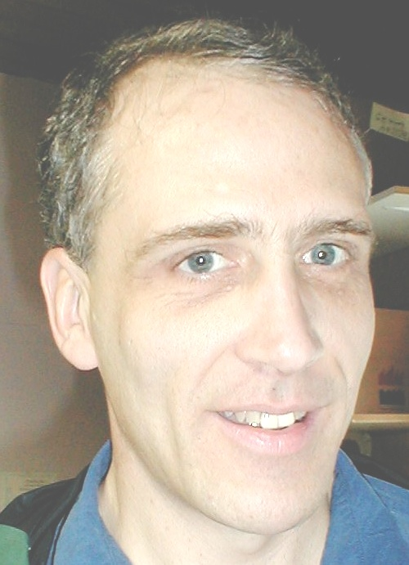
Introducing a radically different treatment for “psychosis”
Presenter: Ron Unger LCSW

Open Dialogue treatment
- Has the best reported recovery rates for people diagnosed with psychosis
- In most cases, no antipsychotic drugs are used
- Involves consumers, families & friends in all key decisions
- Offers immediate, flexible and individualized help
- Values a diversity of voices & perspectives
- Developed in northern Europe, with our help may come to US

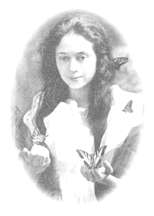
Started in 2007, this quarterly free public forum in Eugene is named after Opal Whiteley [1897 – 1992], a famous author with a psychiatric diagnosis who lived in Lane County.

FREE
1.25 NASW CEU’s Available

More info: Office phone: 541-345-9106 Email: lane@mindfreedom.org
More on Open Dialogue at http://bit.ly/fgG2bu

All are welcome. All agencies and organizations that work in mental health in Lane County are encouraged to send representatives to share your news.

We especially invite mental health consumers and psychiatric survivors to attend, join and speak out!

Free refreshments. Sign language with 72 hours notice. Wheelchair accessible.

Opal Network event: A Lane County coalition to support the voice, self-determination and empowerment of users of mental health services.

Thank you to Opal Network Sponsors:
Center for Family Development • City of Eugene Human Rights Commission • Direction Service • Lane County Mental Health Consumer/Survivor Advisory Council • Lane Independent Living Alliance • Laurel Hill Center • Life & Universe • MindFreedom Lane County • Oregon Consumer/Survivor Coalition • Oregon Family Support Network • ShelterCare • Trauma Healing Project

